经三 王泽源 19317278 计量周四班 第三章作业

Do file

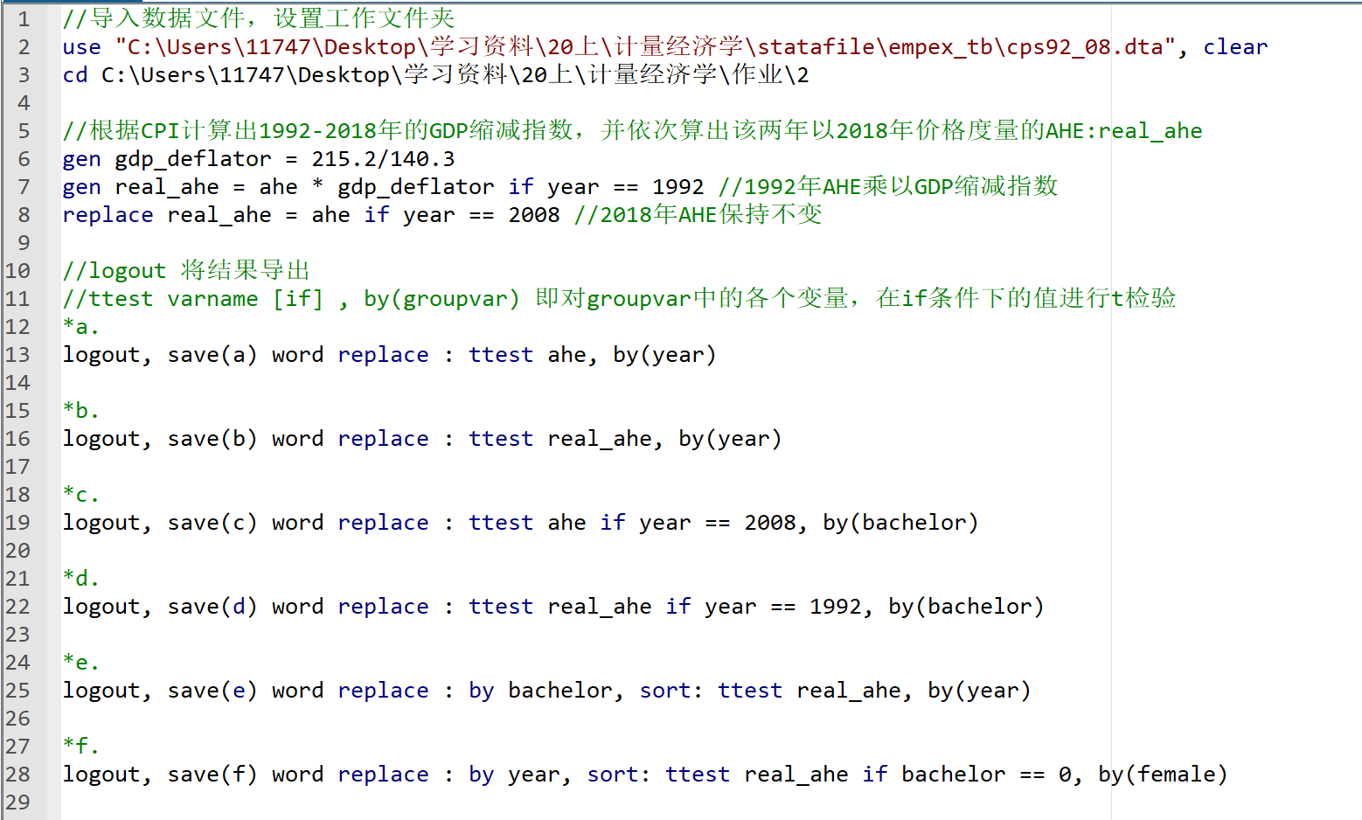

a.1992, 2008 AHE均值

|  |  |  |  |  |  |  |
| --- | --- | --- | --- | --- | --- | --- |
| Group | Obs | Mean | Std.Err. | Std.Dev. | 95% Conf. | Interval |
| 1992 | 7,605 | 11.63 | 0.0644 | 5.613 | 11.50 | 11.75 |
| 2008 | 7,711 | 18.98 | 0.115 | 10.14 | 18.75 | 19.20 |
| combined | 15,316 | 15.33 | 0.0727 | 8.995 | 15.18 | 15.47 |
| diff |  | -7.350 | 0.133 |  | -7.610 | -7.090 |

b.1992, 2008 AHE均值（以2008美元价格计算）

|  |  |  |  |  |  |  |
| --- | --- | --- | --- | --- | --- | --- |
| Group | Obs | Mean | Std.Err. | Std.Dev. | 95% Conf. | Interval |
| 1992 | 7,605 | 17.83 | 0.0987 | 8.610 | 17.64 | 18.03 |
| 2008 | 7,711 | 18.98 | 0.115 | 10.14 | 18.75 | 19.20 |
| combined | 15,316 | 18.41 | 0.0762 | 9.428 | 18.26 | 18.56 |
| diff |  | -1.143 | 0.152 |  | -1.441 | -0.845 |

c.可以采用b小题中的结论，因为购买力一方面取决于名义工资，一方面取决于物价。工人的购买力取决于其名义收入除以消费者价格指数CPI，而b小题中所得以2008年美元计价的收入正是通过此方法得出的，所以可以采用。

d. 2008高中、学士AHE及其差值的95%置信区间

|  |  |  |  |  |  |  |
| --- | --- | --- | --- | --- | --- | --- |
| Group | Obs | Mean | Std.Err. | Std.Dev. | 95% Conf. | Interval |
| High School | 4,002 | 15.33 | 0.122 | 7.701 | 15.09 | 15.57 |
| Bachelor | 3,709 | 22.91 | 0.180 | 10.95 | 22.56 | 23.26 |
| combined | 7,711 | 18.98 | 0.115 | 10.14 | 18.75 | 19.20 |
| diff |  | -7.577 | 0.214 |  | -7.997 | -7.156 |

e. 1992高中、学士AHE及其差值的95%置信区间(2008美元表示)

|  |  |  |  |  |  |  |
| --- | --- | --- | --- | --- | --- | --- |
| Group | Obs | Mean | Std.Err. | Std.Dev. | 95% Conf. | Interval |
| High School | 4,643 | 15.31 | 0.103 | 7.052 | 15.11 | 15.52 |
| Bachelor | 2,962 | 21.78 | 0.171 | 9.319 | 21.45 | 22.12 |
| combined | 7,605 | 17.83 | 0.0987 | 8.610 | 17.64 | 18.03 |
| diff |  | -6.470 | 0.188 |  | -6.839 | -6.101 |

f.

1.1992, 2008高中AHE均值，高中毕业生AHE基本没有变化

|  |  |  |  |  |  |  |
| --- | --- | --- | --- | --- | --- | --- |
| Group | Obs | Mean | Std.Err. | Std.Dev. | 95% Conf. | Interval |
| 1992 | 4,643 | 15.31 | 0.103 | 7.052 | 15.11 | 15.52 |
| 2008 | 4,002 | 15.33 | 0.122 | 7.701 | 15.09 | 15.57 |
| combined | 8,645 | 15.32 | 0.0791 | 7.359 | 15.17 | 15.48 |
| diff |  | -0.0185 | 0.159 |  | -0.330 | 0.293 |

2.1992, 2008学士AHE均值，大学毕业生AHE有5%左右的下降

|  |  |  |  |  |  |  |
| --- | --- | --- | --- | --- | --- | --- |
| Group | Obs | Mean | Std.Err. | Std.Dev. | 95% Conf. | Interval |
| 1992 | 2,962 | 21.78 | 0.171 | 9.319 | 21.45 | 22.12 |
| 2008 | 3,709 | 22.91 | 0.180 | 10.95 | 22.56 | 23.26 |
| combined | 6,671 | 22.41 | 0.126 | 10.27 | 22.16 | 22.66 |
| diff |  | -1.125 | 0.253 |  | -1.621 | -0.630 |

3. 高中毕业生与大学毕业生收入差距可由e题中得到。

1992年，高中与大学AHE差值均值为6.470，标准误差为0.188，95%置信区间为6.101至6.839。

2008年，高中与大学AHE差值均值为7.577，标准误差为0.214，95%置信区间为7.156至7.997。

根据两年AHE差值的均值与95%置信区间的比较得，收入差距可信度很高地变大了。

g.

1992年与2008年美国25-34岁之间高中毕业的全职工人每小时收入变动趋势

|  |  |  |  |  |  |  |  |  |  |  |
| --- | --- | --- | --- | --- | --- | --- | --- | --- | --- | --- |
|  | Male | | | Female | | | Different | | | |
| Year | Mean | Std.Dev. | Obs | Mean | Std.Dev. | Obs | Diff | Std.Err. | 95%Conf. | Interval |
| 1992 | 16.55 | 7.456 | 2,769 | 13.48 | 5.957 | 1,874 | 3.067 | 0.206 | 2.663 | 3.471 |
| 2008 | 16.59 | 8.158 | 2,537 | 13.15 | 6.27 | 1,465 | 3.436 | 0.247 | 2.952 | 3.92 |